SWIS Data Interpretation Activity
- Define a precise, school-wide behavior problem.
- What is the problem behavior(s)?

- How often does the problem occur?

- Where is the problem most likely to occur? Where least likely?

- When is the problem most likely to occur? When Least likely?

- Who is most likely to be engaged in the problem?

- When the problem occurs, what consequences are most likely to be sustaining (rewarding) it?

- Add data to the graphs below to document the problem you have defined.

- Share your graphs with others and determine if they can identify the same problem you attempted to depict.
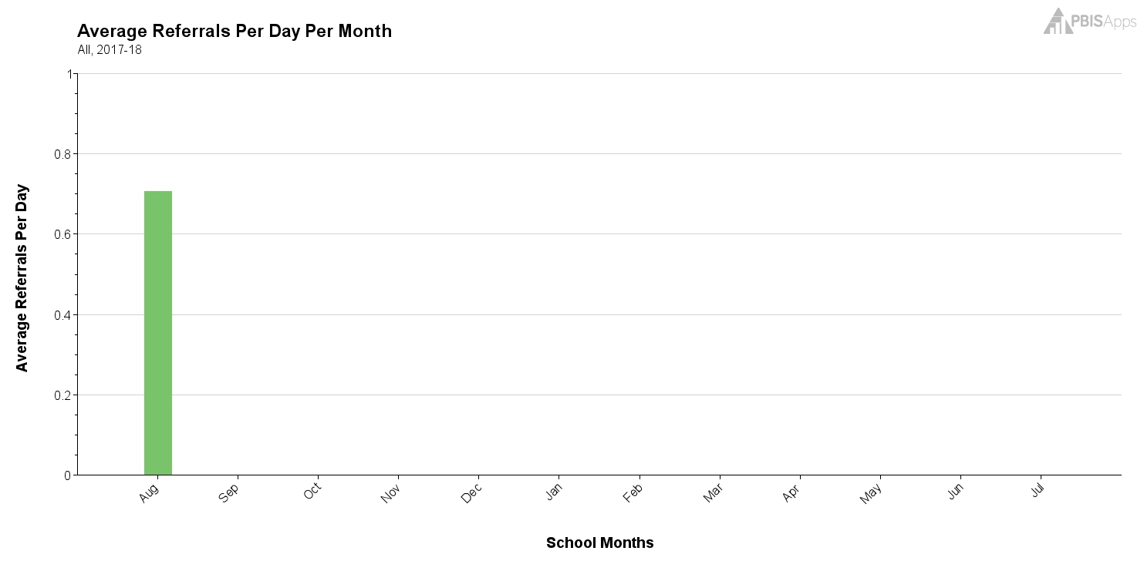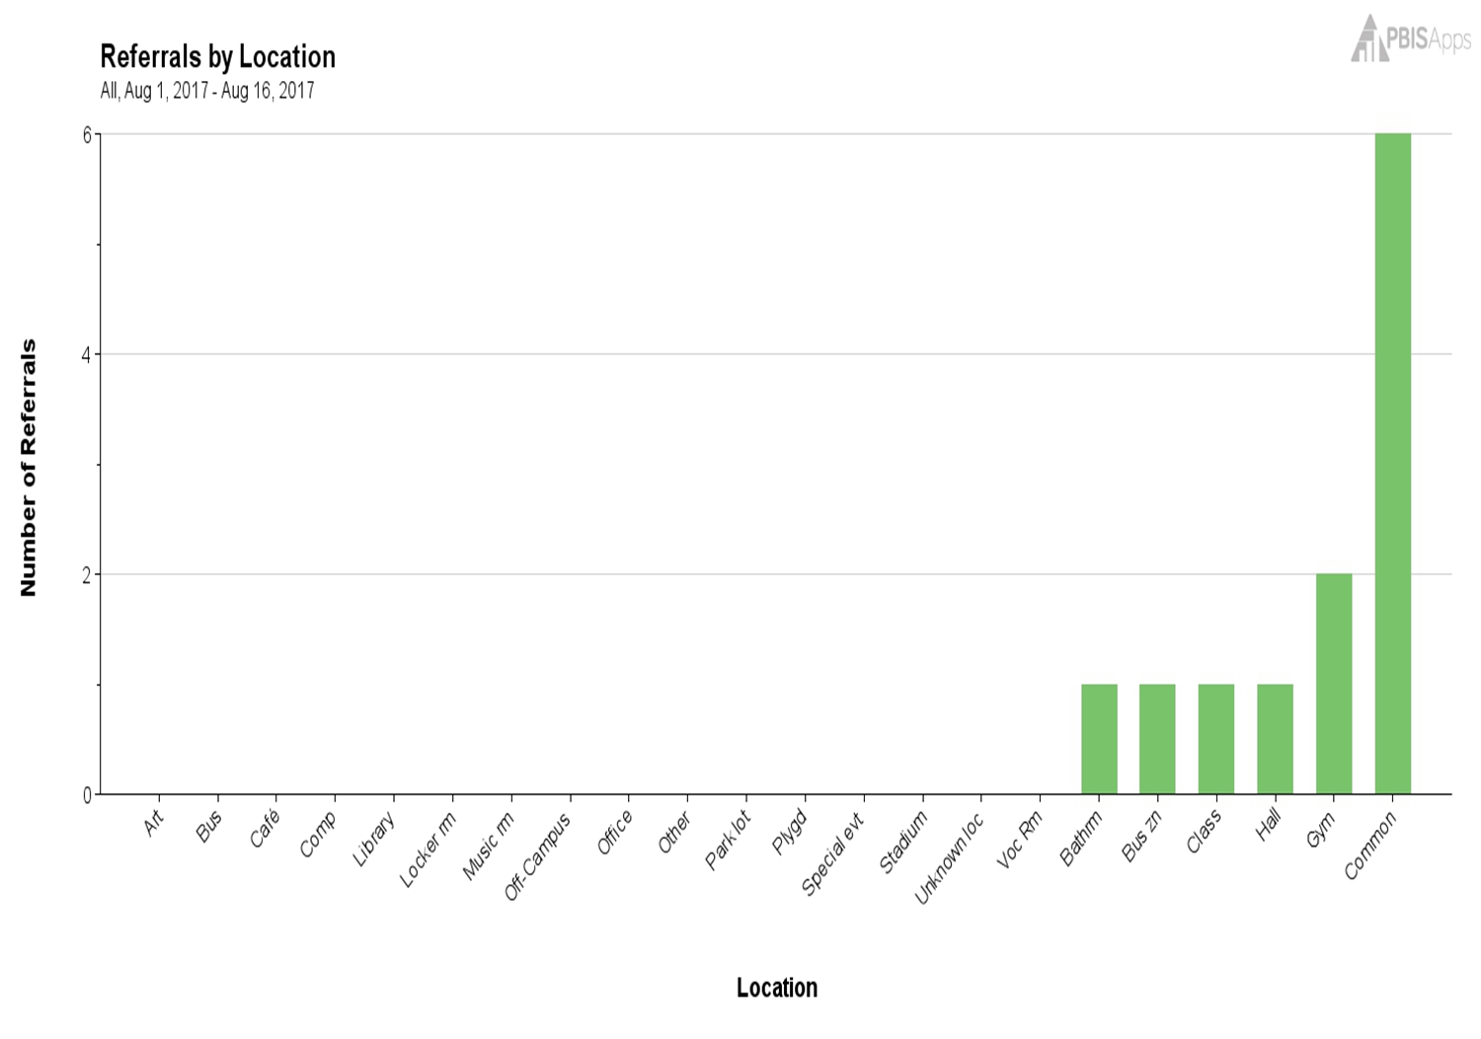
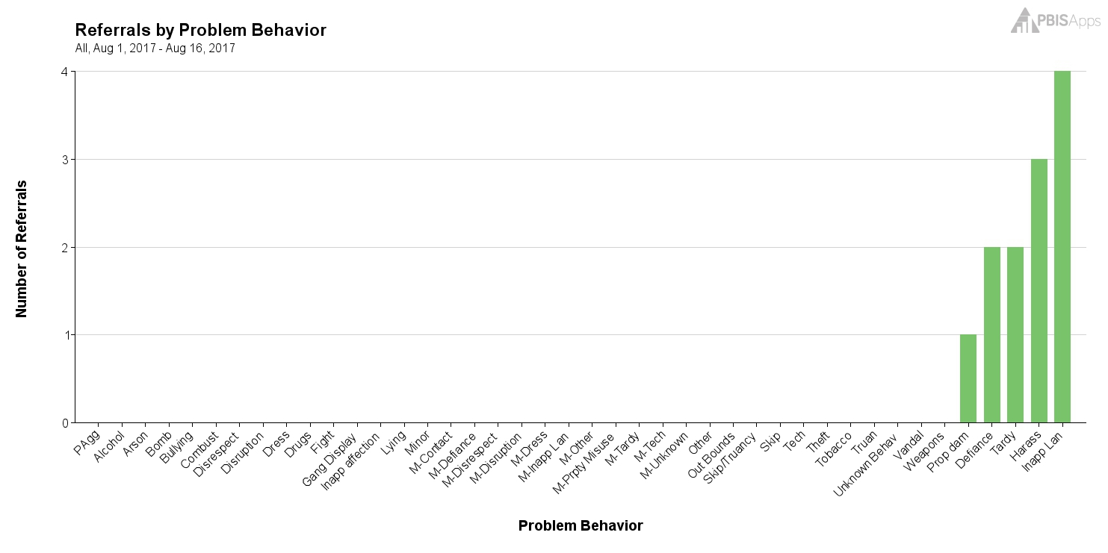
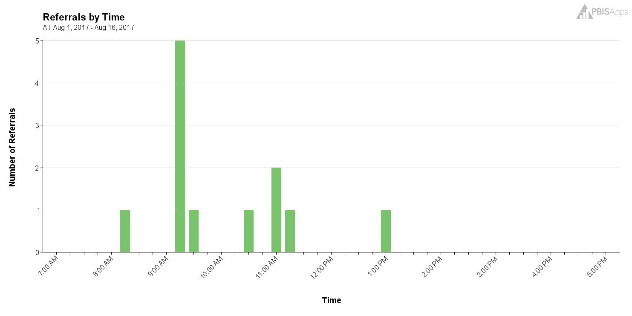
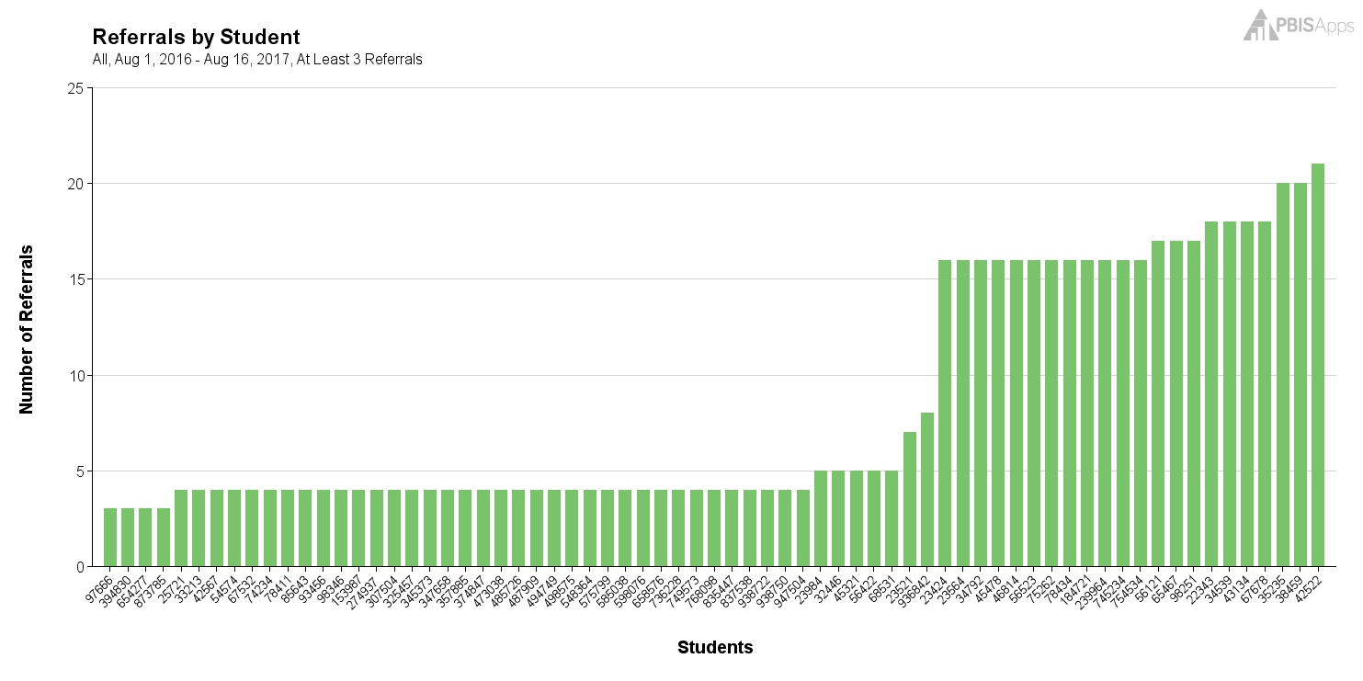

Given: Student(s); Problem Behavior; Location…What is the most likely maintaining motivation?
